STRONGSVILLE
ATHLETIC
BOOSTERS
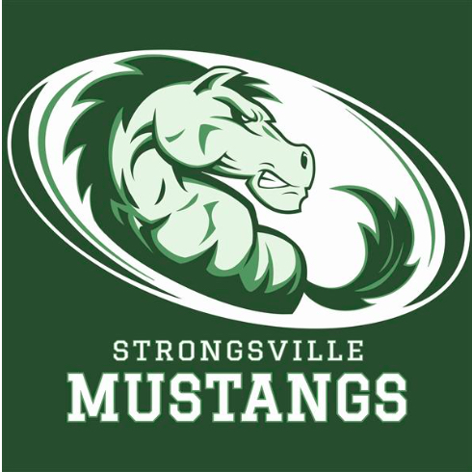

October 8, 2018
MEETING AGENDA WITH MINUTES

I. Call to order
- 19 in attendance

II. Pledge of Allegiance

III. President’s Report – Dan Martin
- Students will be let in for free excluding Football and Boy’s Basketball; one year trial – hope to increase attendance. This also includes Middle School. 103 at first volleyball game. We will keep track moving forward.

IV. Interim Athletic Director’s Report: per Ray Ebersole
- Final Forms introduced; students will be able to fill out forms online and will be available to coaches online instead of a paper trail.
- Boys Golf qualified to districts

V. Treasurer’s Report – Keith Housum
- Provided commitment sheet and expense report
- Currently parking is a couple hundred under last YTD. Made $9,400.00 after 500.00 was given (per team) that volunteered.
- Sold out of Homecoming Programs

VI. Fundraising Chair’s Report – Robin Micko

A. Car Raffle – Fall of 2018
- Chevy Cruze donate by Serpentini
- 3000.00 tickets to be sold; 20.00 a piece ($10.00 to team, $10.00 to turf project)
- Last year made a little over $50,000. Goal is $60,000 this year.
- Feb. 9th Nite at the Races
- October 26, 2018 drawing to be held

VII. Committee Reports

A. Membership Update – Laura Housum
- Membership 243 members, $19,610.00 to date.
- Looking ways to have free parking at Football games next year.

VIII. Team Delegate Update
- Boys Basketball; building their feeder system creating a travel league.
- Don Berkey representing tennis committed to their courts project. Have fundraising projects in place to help them move forward in getting project done. $300.000.00 project. Applied for USTA grant with a good chance of receiving. Currently 38 girls enrolled in tennis. 13-6 tied for best record. Paige Myers record of 75 career wins.
- Girl’s volleyball 19-1 record. $3,400.00 raised at Kailee Mayer fundraiser.

IX. Adjournment

