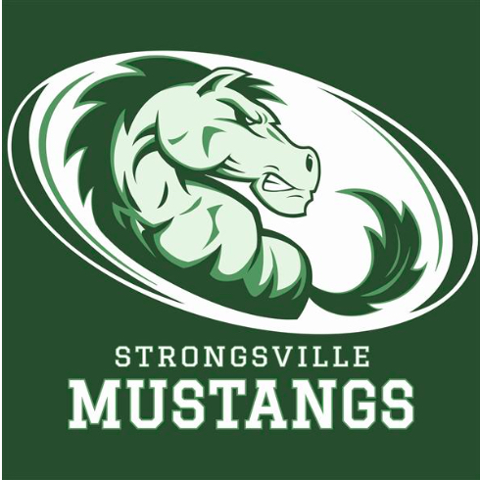
STRONGSVILLE ATHLETIC BOOSTERS

September 9, 2019

MEETING AGENDA with minutes

I. Call to order
- 17 present

II. Pledge of Allegiance

III. President’s Report – Dan Martin
A. Photo donations through Scott Mayberry
- -Scott Mayberry writing articles on behalf of the athletes to
Submit to paper
- Scott is taking pictures of our teams and athletes,
- Contributing part of monies back to boosters
- 11 x 17 posters are $15.00, $4.00 Of which will go back to boosters
- Team Strongsville hosting tailgate Friday, September 13th
- Boosters will have table at tailgate selling old shirts, blankets and selling memberships
- 33 vendors attending
- Concessions at Brown’s games very successful sports teams benefiting from the monies, boosters not taking any money from this fundraiser, all going to the teams

IV. Athletic Director’s Report – Denny Ziegler
- Michael Lee broke record for Boy’s Golf shooting a 68
- Girl’s Golf 8-1
- Boy’s Soccer 6-1-1
- Girl’s Soccer lost to Anthony Wayne on Saturday
- Football 2-0
- Volleyball lost to St. Joes currently 4-2
- Currently looking for a conference to join us, next year there will be a lot of movement, don’t know exactly what that means for us
- Cross Country invite next Saturday, over 1,000 runners coming to Strongsville
- Jordan Halucki named All American in swimming
- Automated camera will be installed in gym to live stream games within the next couple weeks. Looking to potentially add cameras outside for Football and LAX
- Trying to start a reading program for athletes to read to our youth in the community
- Will be naming an athlete of the month, coaches should send nominations to Denny
- Canes committed to $7,500.00 for the next 3 years; $5,000.00 cash and $1500.00 in donations and gift cards, monies will go to boosters

V. Treasurer’s Report – Sara Bass
- Sheet provided with a detailed financial report
- $19,000.00 to date in booster memberships
- $13,000.00 in sponsors for sports program, over $20,000.00 coming in total
- $8,000.00 to print programs
- $5,000.00 boosters paid to Hudl program
- Looking to pay for some uniforms shortly

VI. Vice President’s Report—Keith Housum
- Not present (at meet the candidates night)

VII. Fundraising Chair’s Report – Robin Micko
- Not present (at meet the candidates night)
- Per Robin; 700 unclaimed tickets still available for the car raffle, drop off next Monday 9/16 @ 7:00pm and 10/1 in cafeteria. Drawing is October 4th

VIII. Committee Reports

IX. Team Delegate Updates
- Girl’s Tennis 5-6 , young team
- JV tennis 7-1
- Tennis Conference tournament next week @ Medina , Strongsville is the host team
- Volleyball hosting a Volley for Miles Fundraiser October 3rd, also attending a power 4 in Columbus

X New Business

XI. Adjournment

