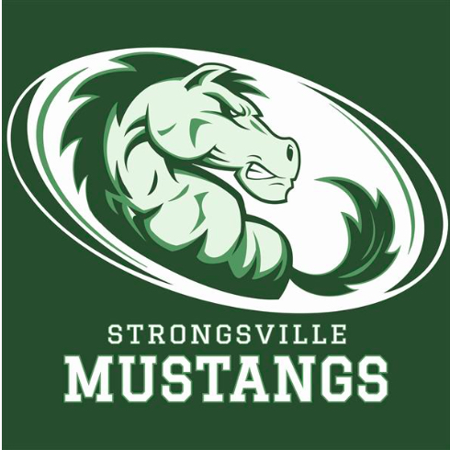
Strongsville Athletic Boosters

May 13, 2019
MEETING AGENDA
I. Call to order
- 12 present
II. Pledge of Allegiance
III. President’s Report – Dan Martin
- Square 22 wanted to do a fundraiser, designated a certain percentage of sales to go to a certain team
- Robin met with the Cleveland Browns.wanting to offer us opportuntites for fundraising… more info to come.
- Dan Foust pushing out Ville t-shirts through social media
- Cassie Martin 4th in the ACC and All Academic, Richard Floyd 3rd in ACC, Mo Abusway broke collar bone for the second time
- Rib burn off coming up, possibly trying to bring back instant bingo. Special Olympics sponsoring corn hole tournament. Dan will follow up with Attorney General regarding bingo. Kendra to look into the instant bingo account.
IV. Athletic Director’s Report – Denny Ziegler
- Evelyn retiring on June 30th, Party 3-6:00 @ Harvest Saloon…Cheryl McCarthy will be taking over her position
- Record boards for LAX will be going up
- Looking into replacing current boards that are damaged and cracked, following up with the company
- Tennis courts…will revisit project now that the levy is over. USTA grant $50,000.00 on top of what we already have. No definite start dates.
- Odell Beckham will be hosting a youth camp at Strongsville High School. Requesting volunteers. 700 kids projected to participate in camp. A certain percentage WILL come back to the boosters.
- SHS will host a meet and greet for incoming freshman… coaches from different sports available to meet and talk about their individualized sport.
- Conference update: Shaker Heights will be leaving in the 2020/21 year.
- Softball: first district show in 9 years
- Baseball: to host sectionals tomorrow
- Track: Districts this week
- Looking into online ticketing, looking to sell tickets in advance and sell them online (able to use credit cards)
- Also looking to sell ads online
- Coaching shifts; Sean Black Head tennis coach, Dawn Thall head girls basketball coach, Oswald Garner assistant boys basketball coach
V. Treasurer’s Report – Keith Housum
- $650.00 Polaris Donation
- Looking for workers for after prom for casino table 11:30pm. -3:00am.
- Monies still to pay out from the car raffle.
- Team success going up
- $16,000.00 in surplus
- Financial report provided
VI. Vice President’s Report – Kendra Jeske
- Dan Martin presented Timmy Ruche with booster scholarship for $500.00
- Sarah Bass to take over for treasurer for boosters, term starts in June
VII. Committee Reports
A. Membership Update – Laura Housum
- Best year by far to date
- Up over $21,000.00

VIII. Team Delegate Updates
IX. New Business

X. Adjournment

