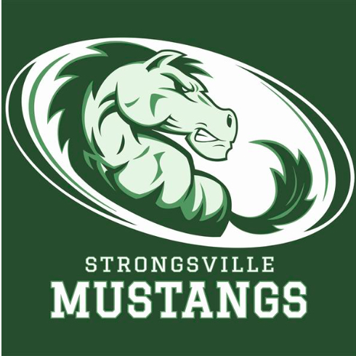
/a
STRONGSVILLE ATHLETIC BOOSTERS

December 10, 2018

MEETING AGENDA WITH MINUTES

I. Call to order

II. Pledge of Allegiance

III. President’s Report – Dan Martin
- Denny Ziegler taking over Jan. 1st.
- Supplied 150 t-shirts to football cheerleaders, coaches, and players. Lost $700.00.
- Soccer made it to the final 4
- New Girls Head Basketball coach named; Dawn Thall
- More kids showing up to sporting events since letting them in for free

IV. Interim Athletic Director’s Report – Dan Martin

V. Treasurer’s Report – Keith Housum

VI. Fundraising Chair’s Report – Robin Micho

A. Car Raffle – Fall of 2018

VIII. Committee Reports

A. Membership Update – Laura Housum

IX. Team Delegate Updates

X. New Business
A. Night at the Races
- event Feb 9, 2019
- Ask coaches to send out email for donation for booze barrel
B. Golf Outing
- Meetings to begin soon for planning

C. Dan Foust presenting boosters with fundraising opportunity
- Bringing more community events to Strongsville
- Harlem Wizards coming to SHS for event Jan. 31st @ 7:00. Game will be against Strongsville teachers and staff. Assembly will be held day of event. Possible fundraiser for Boosters. $10.00 for students, $12.00 general admission.

D. Forging Ahead
- Look into score boards
- Possible video screen
- Padding in entry way
XI. Adjournment

