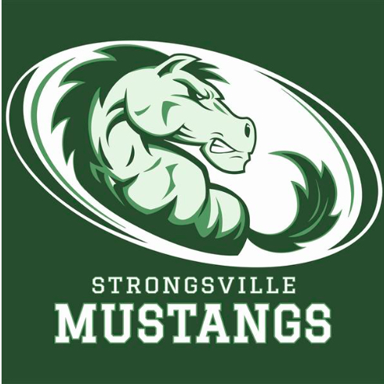
STRONGSVILLE ATHLETIC BOOSTERS

November 12, 2108

MEETING AGENDA WITH MINUTES

I. Call to order
- 19 present

II. Pledge of Allegiance

III. President’s Report – Dan Martin
- Fall sports positive attendance
- Early signing Wednesday at 2:45
- Will try to work on getting conference champs shirts made for those that make it
- Banners look great
-

IV. Interim Athletic Director’s Report – Dan Martin

V. Treasurer’s Report – Keith Housum
- ½ car raffle money back to school district, funds to be spent on kids
- Spreadsheet provided of funds

VI. Fundraising Chair’s Report – Robin Micko

A. Car Raffle – Fall of 2018
- $52,500.00 raised. Surpassed last years
- Soccer players grandfather won car

VII. Committee Reports

A. Membership Update – Laura Housum
- 249 members to date, not including Hockey
- $19,885.00 to date

VIII. Team Delegate Updates
- Girls tennis; influx of freshman, great season and growing, top 8 made it to district, 2 players committed to playing Division III tennis
- Girls Soccer; 19-1-3-, 5 made All Conference, 2 freshman honorable mention, Shelby Salee named All Ohio (only sophomore in history to receive this honor)
- Hockey; started at U of Miami, Wednesday scrimmage, Saturday 17th playing Hudson at KSU
- Boys Cross Country; made it to regional
- Girl’s cross country; 2 girls made it to regional
- Boys Soccer; 15-3-1, lost in the district final

IX. New Business

A. Night at the Races
- February 9, 2019 … looking for volunteers
- First meeting Nov. 28th at market District
B. Golf Outing

X. Adjournment

