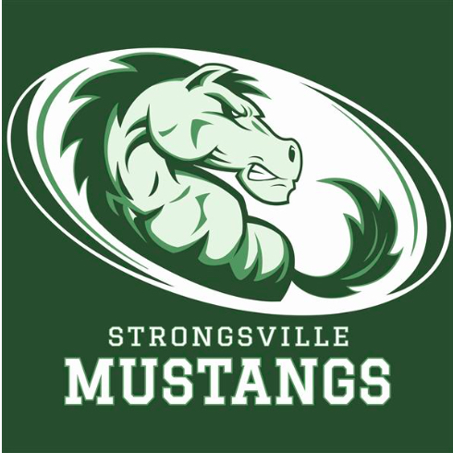

STRONGSVILLE ATHLETIC BOOSTERS

November 18, 2019

MEETING AGENDA WITH MINUTES

I. Call to order
- 15 present

II. Pledge of Allegiance

III. President’s Report – Dan Martin
- Presented scoreboards to school board
- Parking at football game made $2300.00

IV. Athletic Director’s Report – Denny Ziegler
- Last Thursday 13 athletes signed letters of intent
- Most All Conference are out on GCC website
- Meet the mustangs last Wednesday combined middle school with the high school drawing connection with the two
- Trying to create student athlete involvement with elementary schools including a reading program
- Winter sports open up Saturday @ Wooster ; GBB followed by a game at Rocket Mortgage Fieldhouse
- BBB start next Friday against Olmsted Falls
- Discussions cont. regarding scoreboards; run off Apple TV, capability of seeing on your phone with App, each sport has its own individualized template, PE classes can use ie. Heart monitors, looking for installation Dec. 11-20th 2019. Still need to find operators and advertisers.

V. Treasurer’s Report – Sarah Bass
- Provided report

VI. Fundraising Chair’s Report – Robin Micko

A. Night at the Races – Feb. 22, 2020
- Will organize meetings after Thanksgiving
- Winter programs to be pushed out mid Dec.
- Need chair for the Golf Outing

VII. Committee Reports

A. Membership Update – Laura Housum
- 254 members to date
- $20,510.00 total

VIII. Vice Presidents Report – Keith Housum
- Regarding Scorevsion : treasurer are currently working with the lawyers. Looking for board approval to move forward. Hopefully securing Scorevsion to be at the next meeting.

IX. New Business

- Denied in SW Conference , Westlake and North Olmsted going to Amherst

X. Adjournment

