STRONGSVILLE
ATHLETIC
BOOSTERS
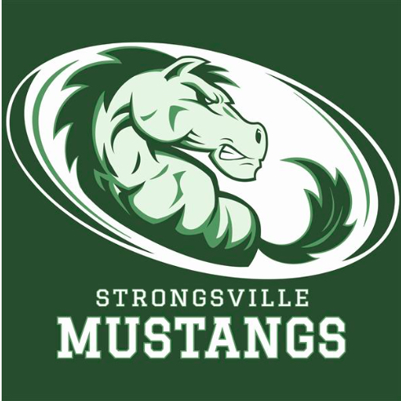

October 12, 2020
MEETING AGENDA WITH MINUTES

I. Call to order – 28 in attendance

II. Pledge of Allegiance

III. President’s report – Keith Housum
- Advertising efforts – we are working on several new and fairly large sponsorships include Ganley Buick GMC, Chick Fil A, Southwest General. Big meeting next Thursday with Chick Fil A to discuss several assets. We still have several small ones too that are actively talking with us. Please send any prospective advertisers our way with any budgets…or even the company you work for if they have spirit funds or matching community donation funds.

IV. Vice President’s Report – Rick Schulz
- Update on Media Guide – we have been selling the Media Guides at soccer, volleyball and football games for $5. Please let us know if anyone wants to buy one we can arrange to get it to them. Booster Club Membership of $100+ gets one included. Great keepsake for athletes and families.

V. Treasurer’s Report – Sarah Bass
- Media Guide advertising sales were $24,000, still a few checks to come in for this but looks good. Another approximately $2,000 in membership proceeds since the last meeting.
- Team delegates – ask your teams/coaches if they need anything for their team, feel free to submit those to us for possible support. Plus many of the teams have money available in their accounts currently for their immediate use.

VI. Athletic Director’s Report – Denny Ziegler
- Great Fall sports season for SHS. Football was unfortunately eliminated from the playoffs. Girls soccer 11-0 and starts the playoffs in another week, ranked #2 in state. Should have home field advantage throughout playoffs. Boys soccer is 7-5, #11 seed for playoffs also starting soon.
- Volleyball in the last week of the season then playoffs, sitting in 2nd place in conference after a really tough schedule and good teams around them. Cross Country meet last Saturday with many PRs across the events, solid performance.
- Boys golf missed state by a couple strokes but a great season. Girls golf tourney tomorrow, 10/13. Tennis teamunfortunately did not proceed forward in playoffs.
- Winter Sports update – at this point all Winter sports are planned to start as scheduled. There are contingency plans if needed. They are most worried about wrestling and the close contact and multiple matches in a day or tournament’s time frame.
- At SHS if we want spectators we need to get creative – for example, boys and girls swim meets on different nights, basketball freshman in the back gym, possibly no cheer or dance at basketball. Hockey will be determined by the OBM Arena. School rules versus conference/state rules are still being ironed out.
- Streaming for playoffs is handled by the state – yet to be determined how/if we can stream.

VII. Fundraiser Chair’s Report – Debbie Yarwood
- Still considering a watch party for one of the playoff games – anyone interested or team delegate thoughts?
- City BBQ fundraiser tomorrow night – Oct. 13th, all day 20% proceed kick-back to us
- Dedicated parking spot sold for $630! Second spot being offered to other high bidders.
- Night At The Races planned for Feb. 22nd if we can have it, sure hoping to do so. We will need to decide by mid-December to pull it off.

VIII. Car Raffle Chair’s Report – Robin Micko and Stephanie Kunovich
- Selling of raffle tickets is underway by Fall sports teams, Winter team sports are next to be contacted to sell. Spring sports may/may not participate. Car is getting stickered and decorated for more attention – be on the watch for it to be displayed. Drawing is Nov. 20th at a basketball game.

IX. Membership Chair’s Report – Laura Housum
- 191 members currently as compared to 270 last year at this time. Please encourage membership to your friends, neighbors, and teams.
- Blankets, magnets, Media Guides are ready for membership pick up at meeting or contact us for pick up. Sweatshirts are still on order.

X. Presentation/Guest Speaker
- AD Denny Ziegler demonstrated the new gym scoreboards – amazing capabilities and creativity is ours to enhance with graphics and pictures on the screen. Really great demonstration. Many advertising opportunities as well. Ads currently scrolling are :15, :30, :45 – really whatever we want. Great way to hype the crowd, introduce line-ups, highlight players and plays. New feature – Moments where we can create 10 second clips and capture video to play back, save, transfer, etc.
- Future enhancements could be additional streaming capabilities at away games, soccer fields, etc. via ipads.
- We are still learning more about the app – but check it out, free download from your app store ScoreVision Fan App where you can access content from the boards.

XI. Coaches or Delegate Team Update Reports – Denny gave the majority of these.

XII. Call for open items, unfinished business, questions – none brought forward

XIII. Adjournment

