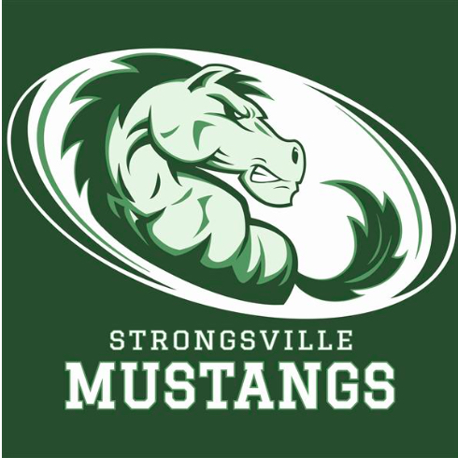
STRONGSVILLE ATHLETIC BOOSTERS

December 9, 2019

MEETING AGENDA

I. Call to order
- 17 present

II. Pledge of Allegiance

III. President’s Report – Dan Martin
- Presentation by Scorevsion

-

IV. Athletic Director’s Report – Dan Martin
- GBB 3-2 road win at Euclid
- BBK 0-3
- Wrestling has 28 athletes participating , loss to Olmsted Falls

V. Treasurer’s Report – Sarah Bass
- $139,000.00 in main account
- Teams; received $39,000.00
- District received $29,000.00
- Projections ; $30,000.00 due
- Report was provided

VI. Vice President’s Report—Keith Housum
- NAR meeting will be scheduled, looking for volunteers
- Looking ahead , want to possibly have large presentation / open house for scoreboards.

VII. Fundraising Chair’s Report – Robin Micko
- One more Browns Game
- Looking for Golf Chair

VIII. Committee Reports

IX. Team Delegate Updates
- Hockey 3-5-1

X New Business

XI. Adjournment

